**Assignment No:-39**

Name:-Suryawanshi Sangramsingh Sambhaji

Batch: - Delta - DCA (Java) 2024 Date:-1/7/2024

**1. Write a program that takes in a string and reverses it.**

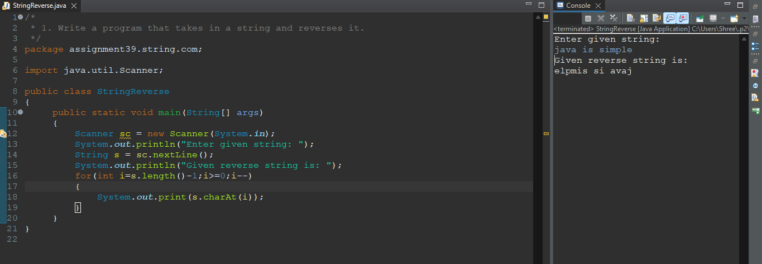

**2. Write a program that takes in a string and counts the number of vowels in it.**

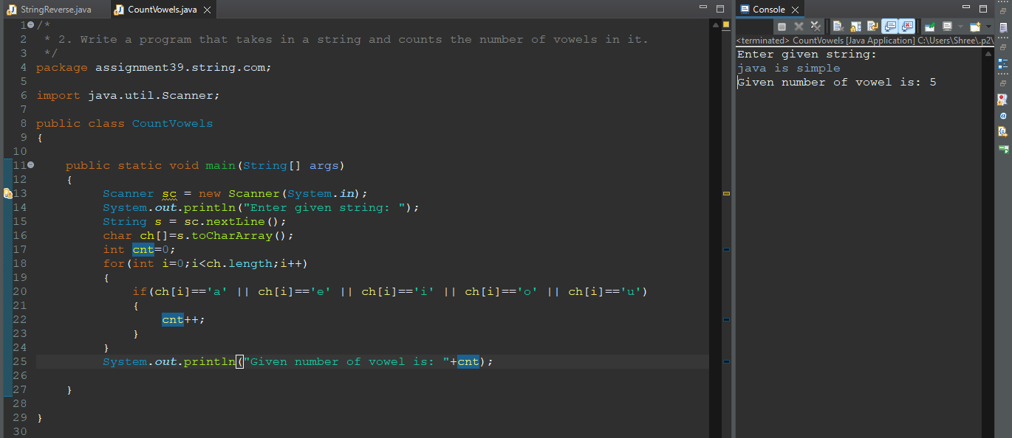

**3. Write a program that takes in a string and checks if it is a palindrome (reads the**

**same forwards and backwards).**

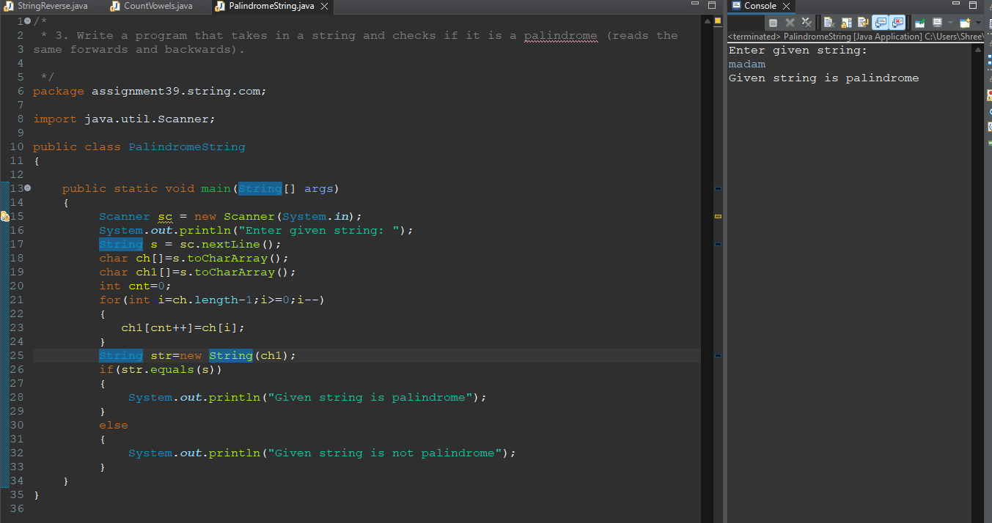

**4. Write a program that takes in a string and finds the longest word in it.**

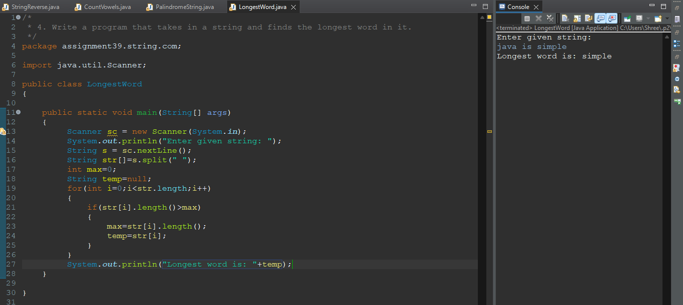

**5. Write a program that takes in two strings and checks if they are anagrams (contain**

**the same letters in different order).**

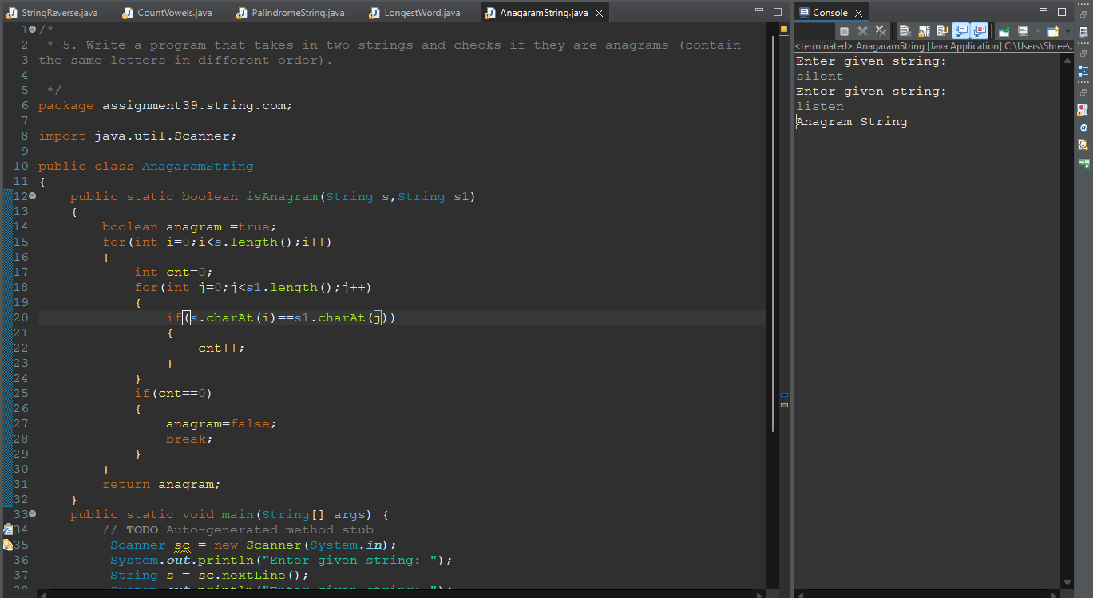

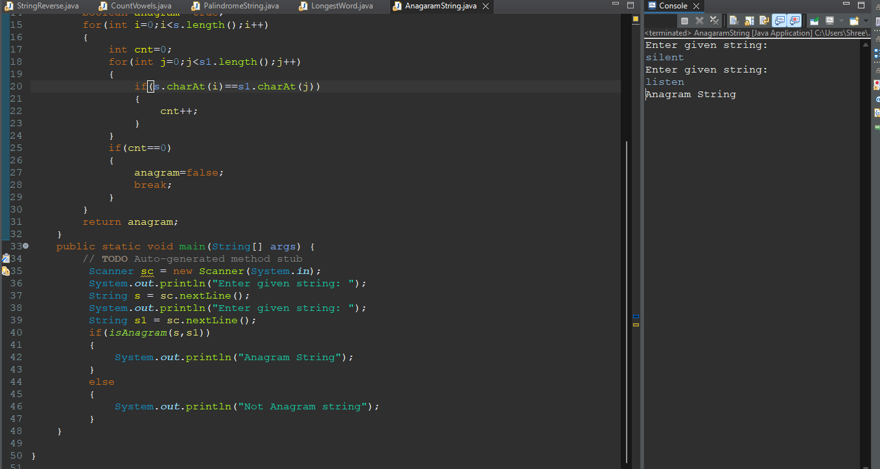

**6. Write a program that takes in a string and removes all the vowels from it.**

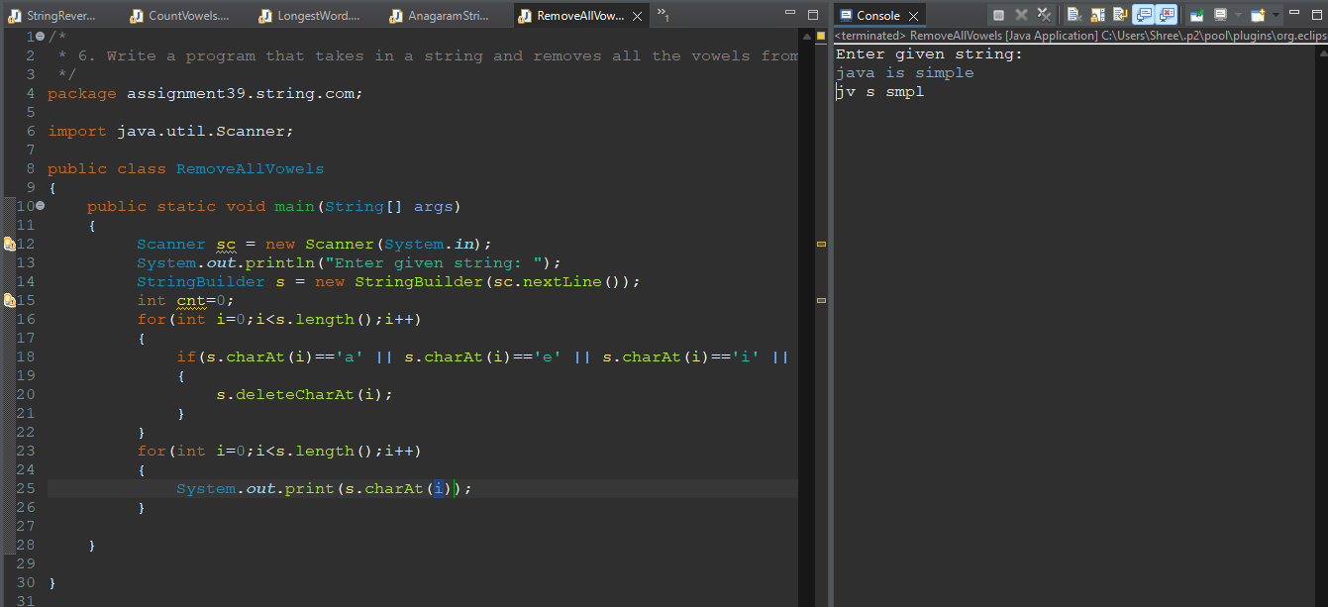

**7. Write a program that takes in a string and converts all the uppercase letters to**

**lowercase.**

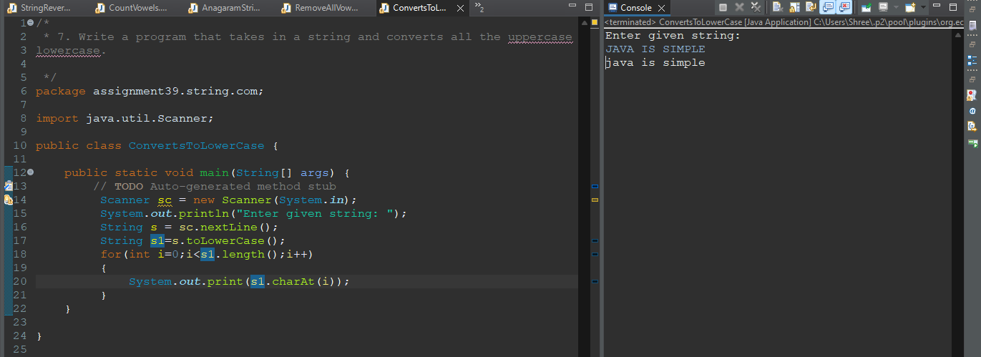

**8. Write a program that takes in a string and replaces all instances of a given substring**

**with another substring.**

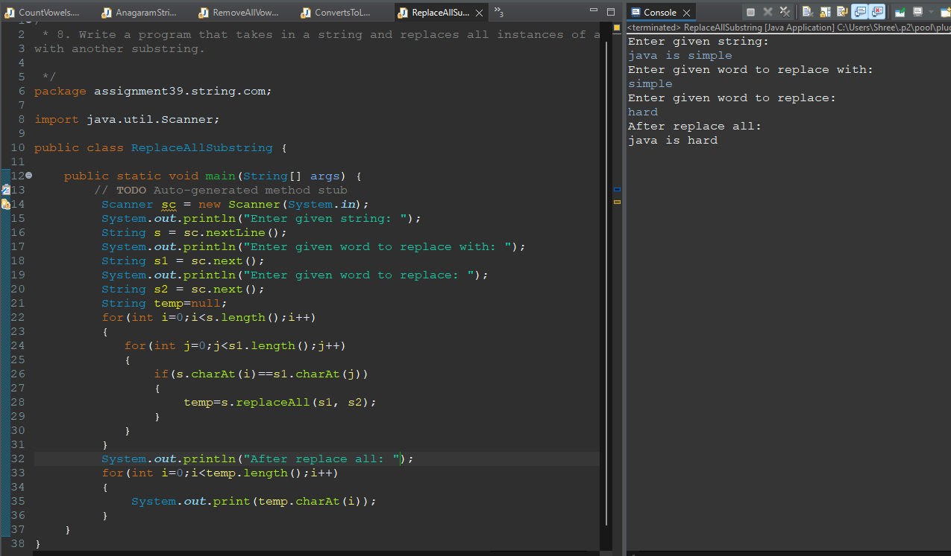

**9. Write a program that takes in a string and finds the first non-repeating character in it.**

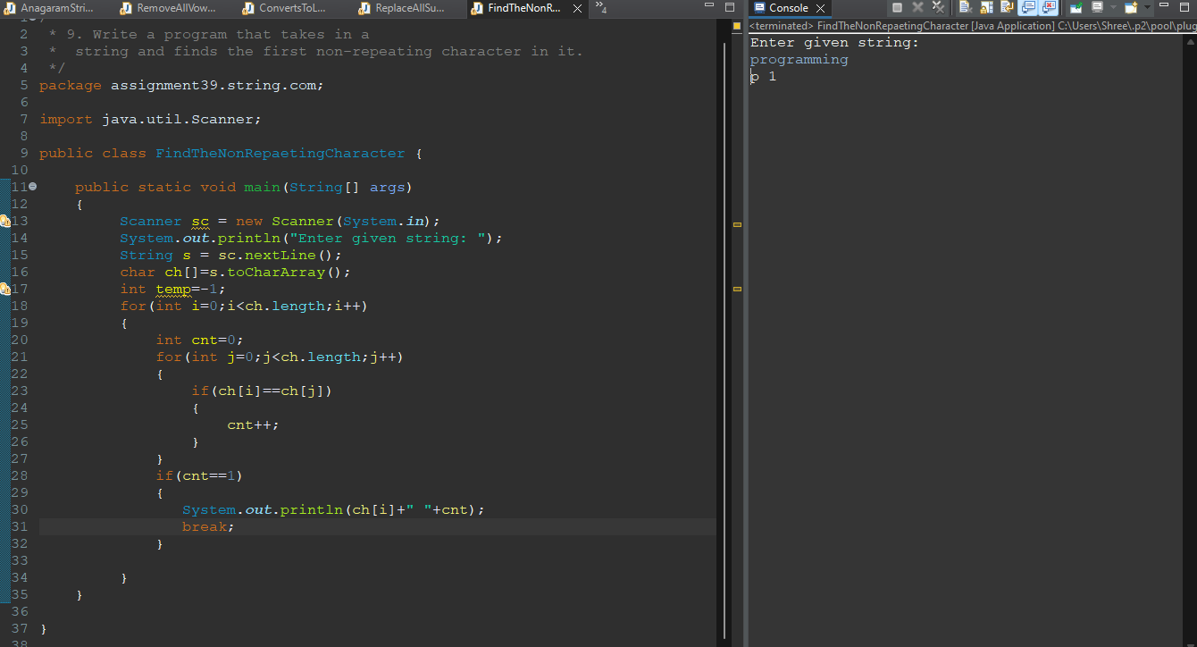

**10. Write a program that takes in a string and removes all consecutive duplicates (leaves**

**only one instance of each character).**

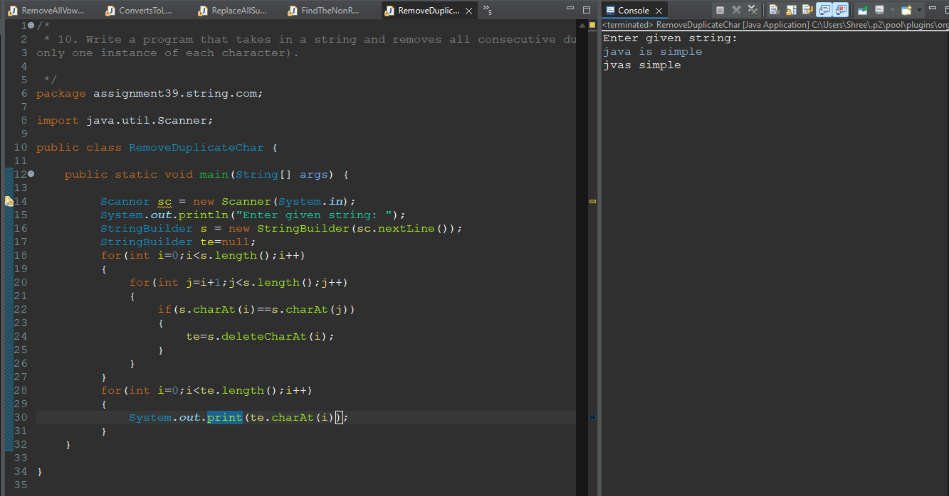

**11. Write a program that takes in a string and finds the most frequent character in it.**

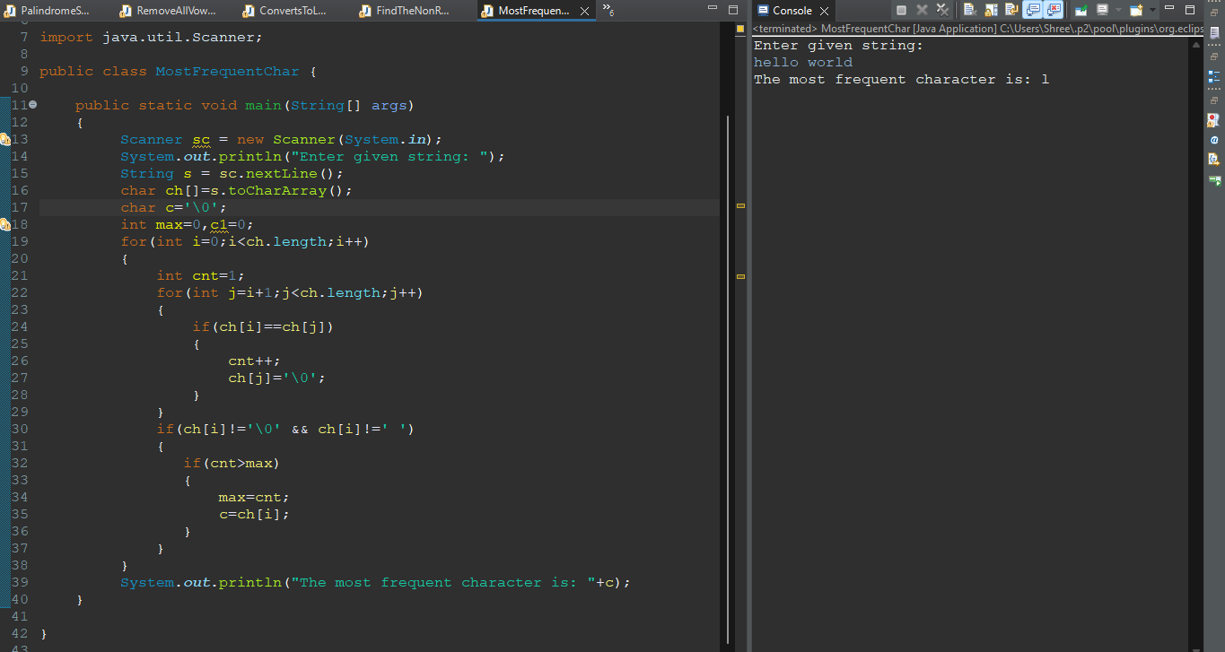

**12. Write a program that takes in a string and checks if it is a valid email address.**

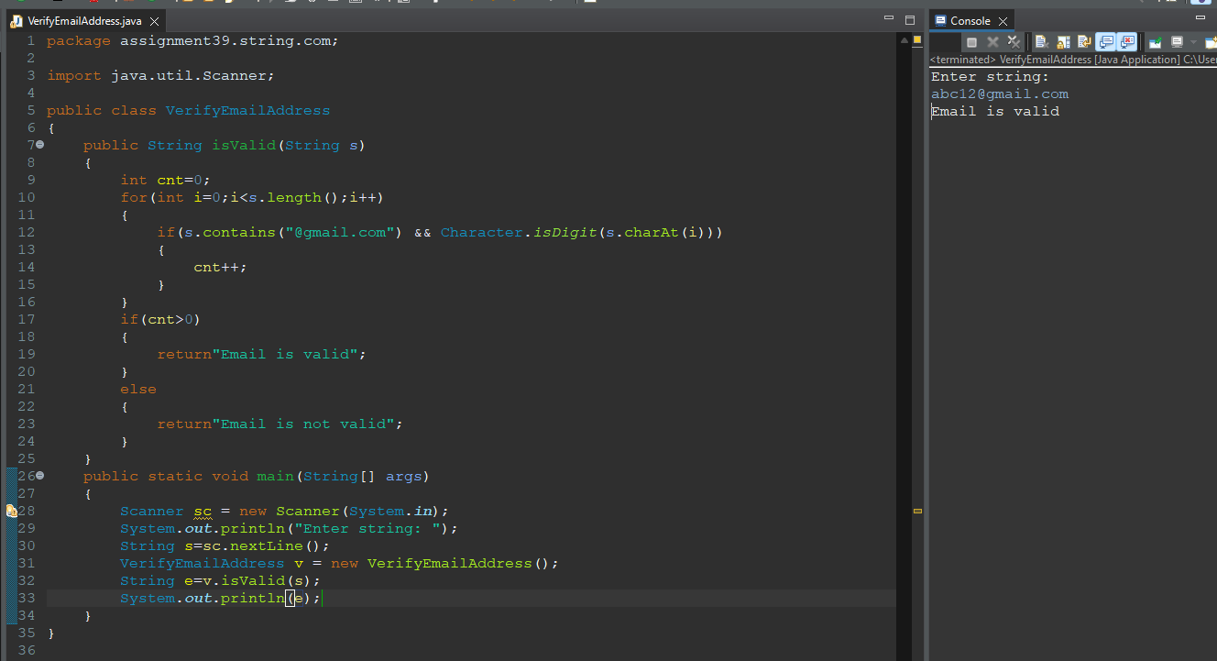

**13. Write a program that takes in a string and checks if it is a valid URL.**

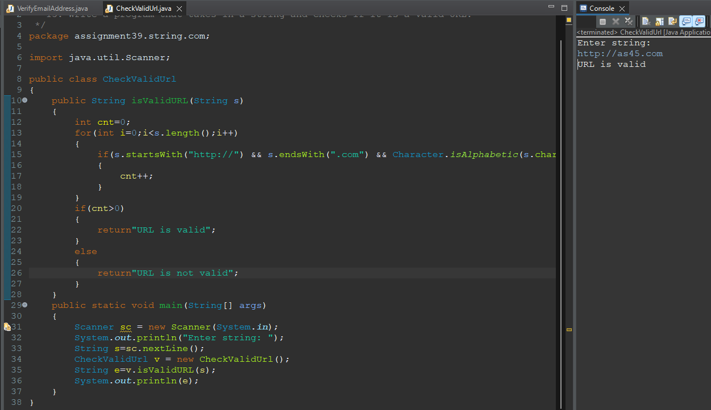

**14. Write a program that takes in a string and checks if it is a valid IPv4 address.**

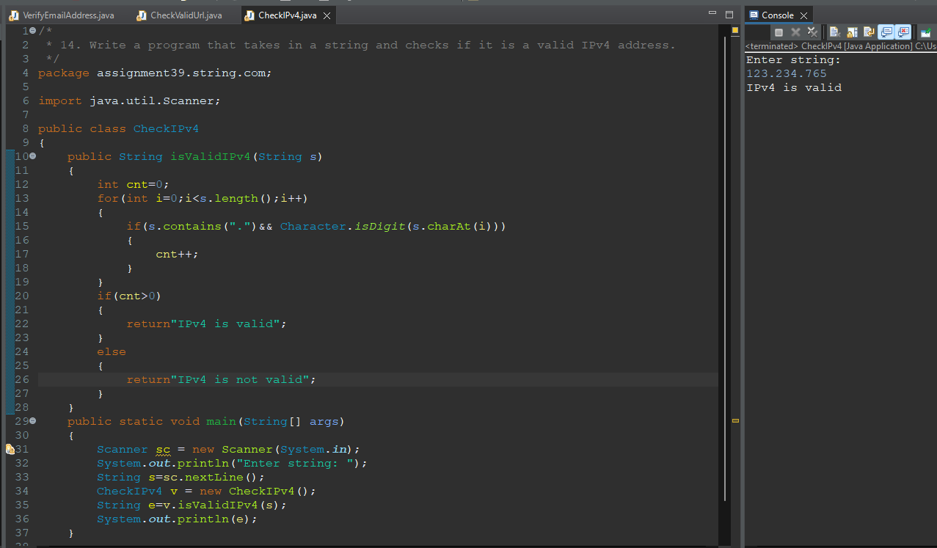

**15. Write a program that takes in a string and capitalises the first letter of each word.**

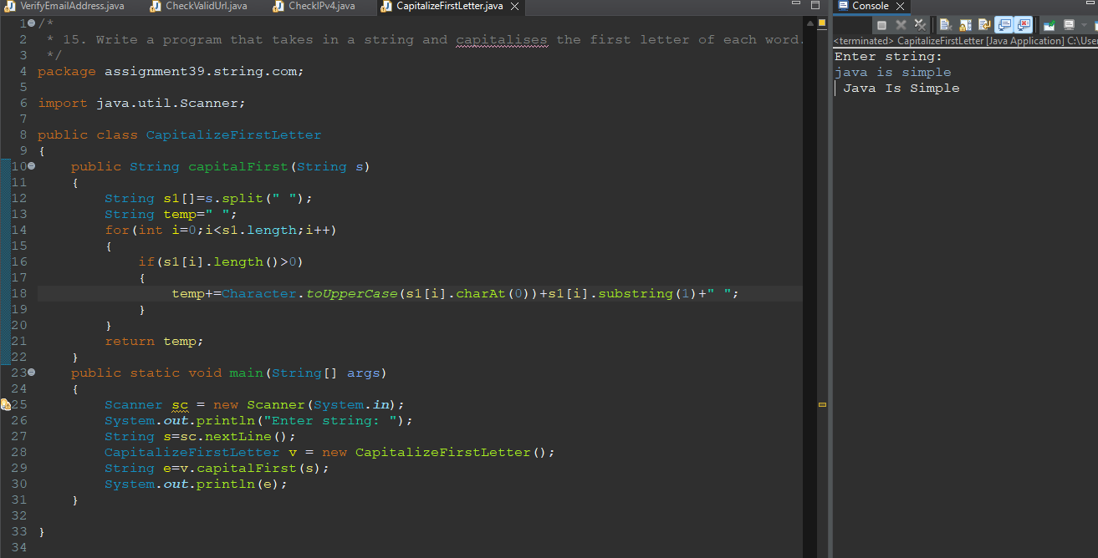

**16. Write a program that takes in a string and returns the characters in reverse order, but**

**preserves the order of words.**

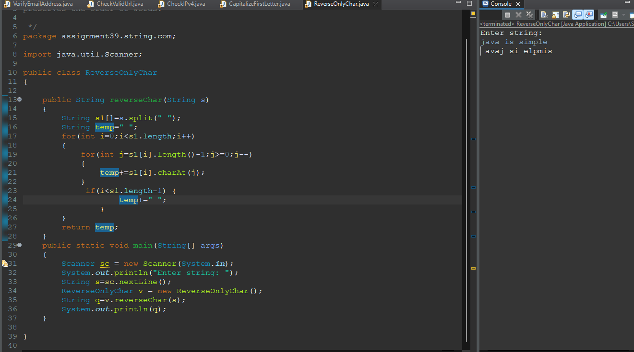

**17. Write a program that takes in a string and removes all punctuation marks from it.**

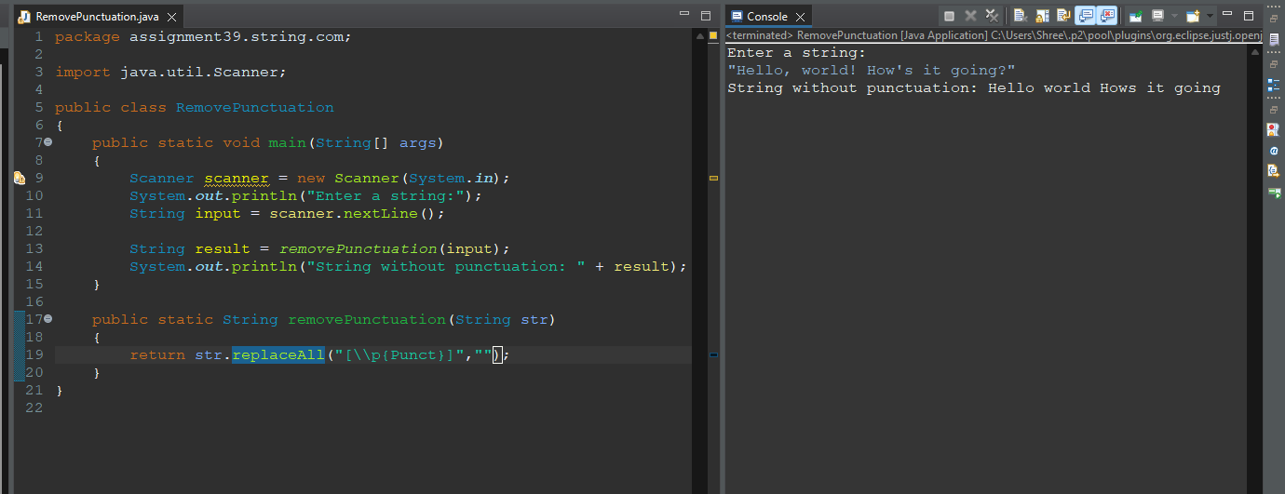

**18. Write a program that takes in a string and checks if it contains only unique**

**characters.**

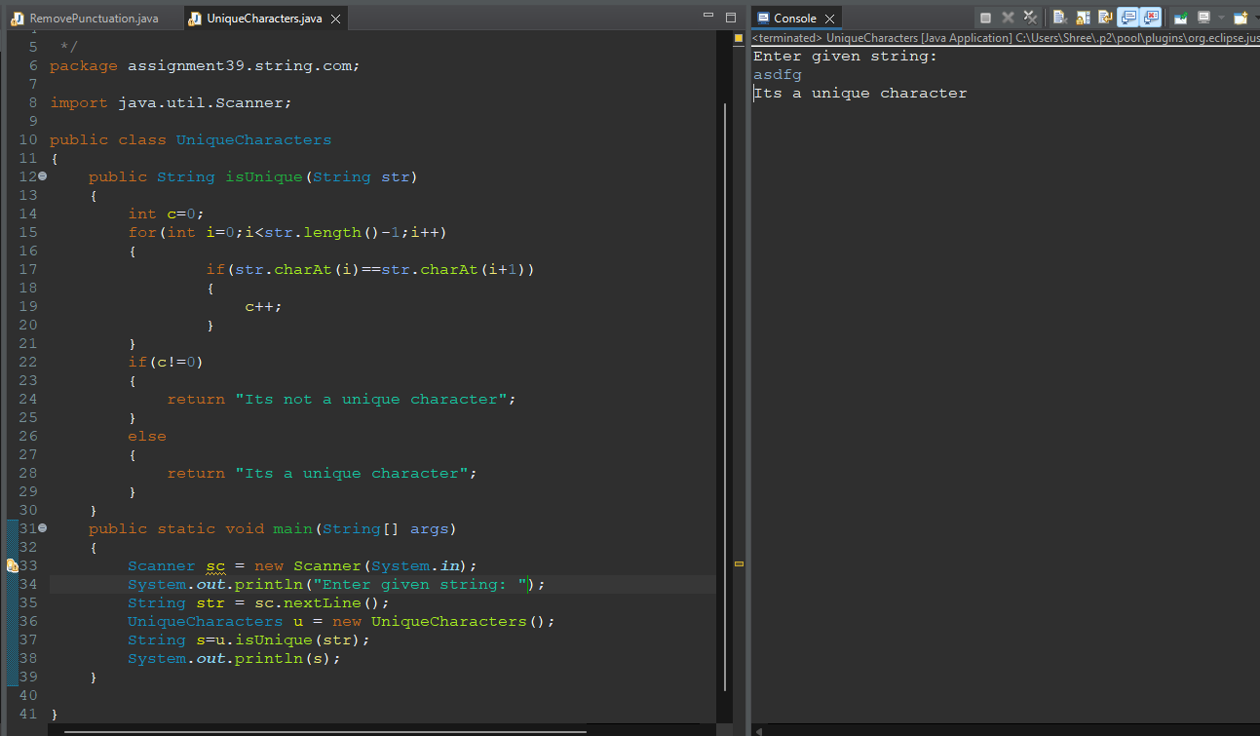

**19. Write a program that takes in a string and returns the second most frequent character**

**in it.**

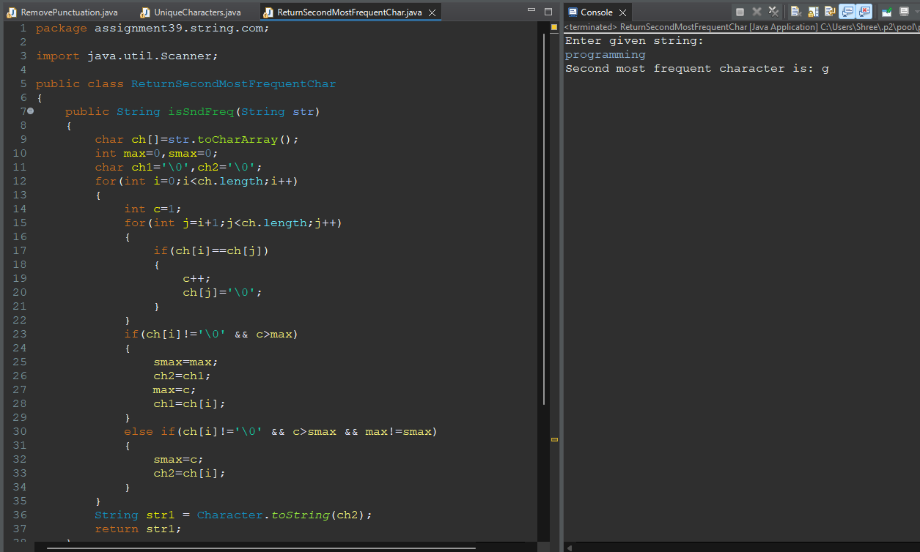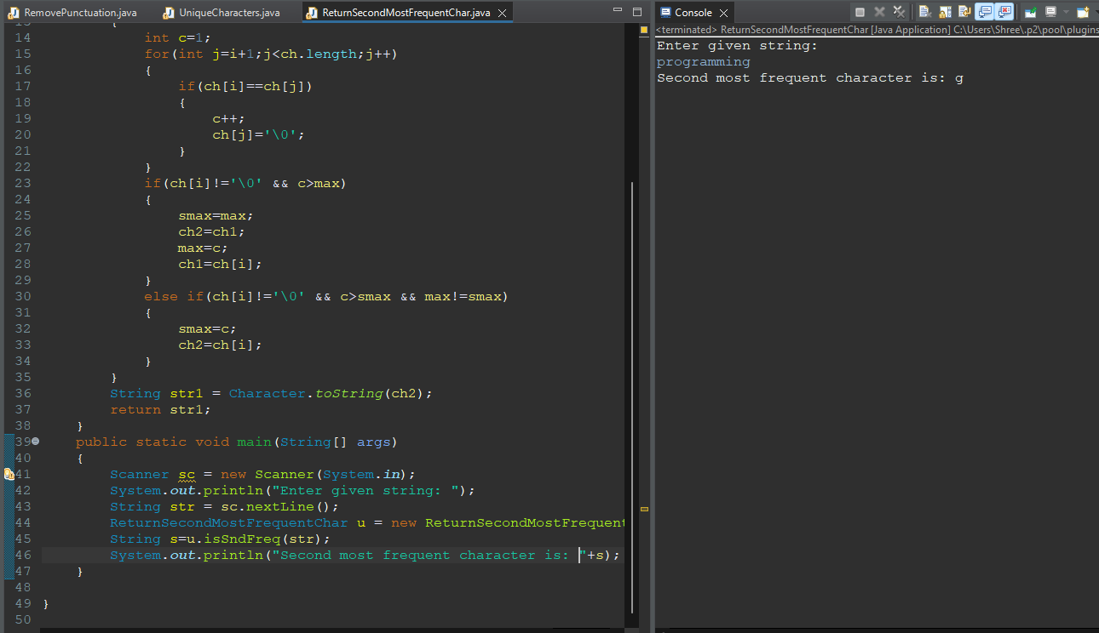

**20. Write a program that takes in a string and checks if it is a valid credit card number**

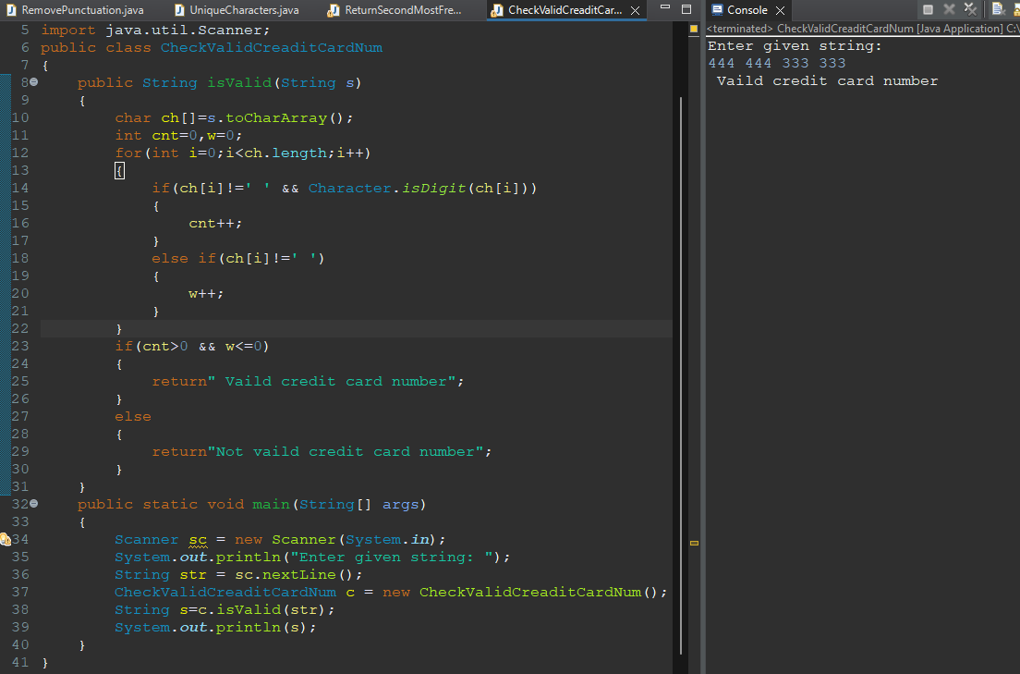

**21. Write a program that takes in a string and returns the first recurring character (i.e. the**

**first character that appears more than once).**

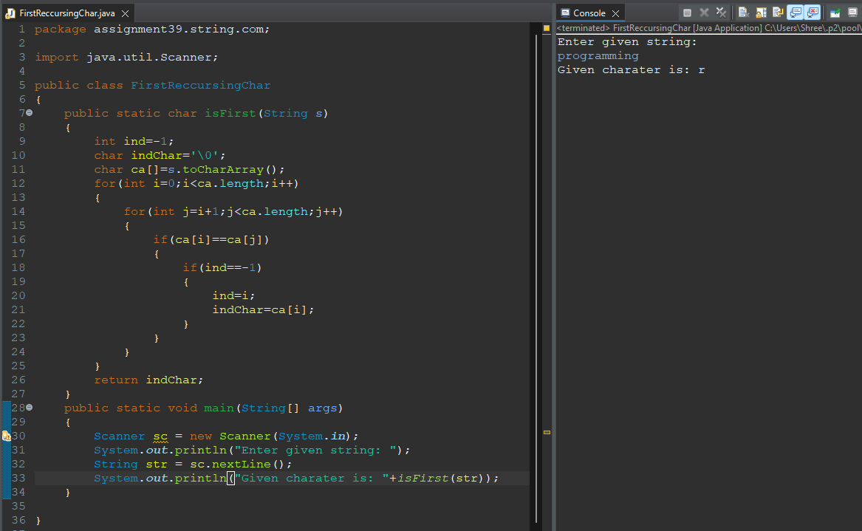

**22. Write a program that takes in a string and checks if it is a valid phone number (in a**

**specific format, e.g. (123) 456-7890).**

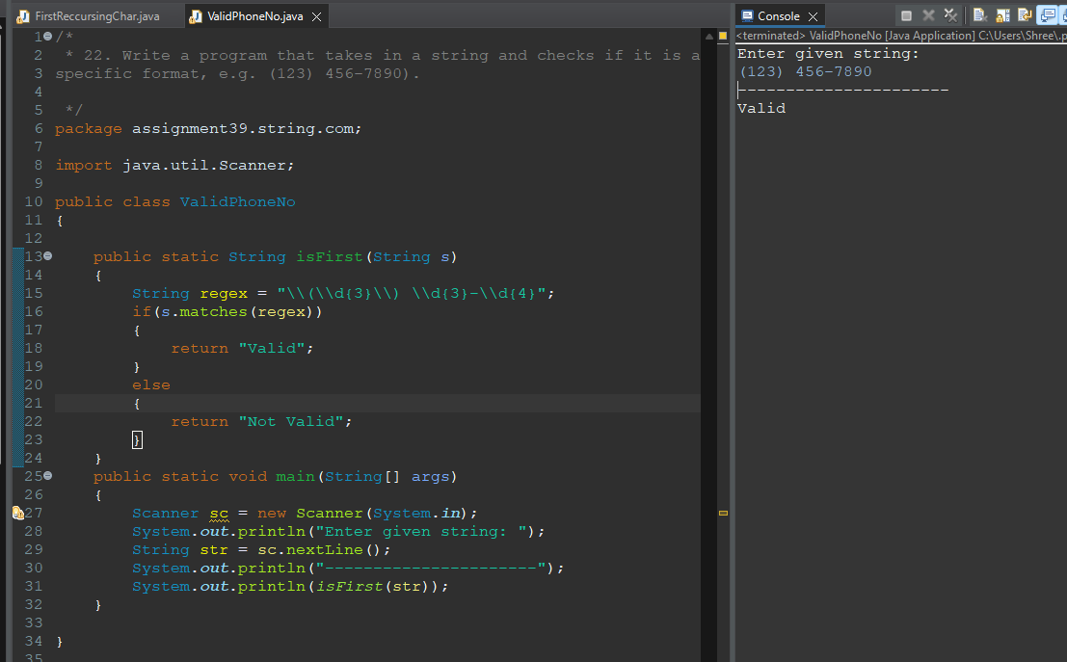

**23. Write a program that takes in a string and returns the most common substring of**

**length k.**

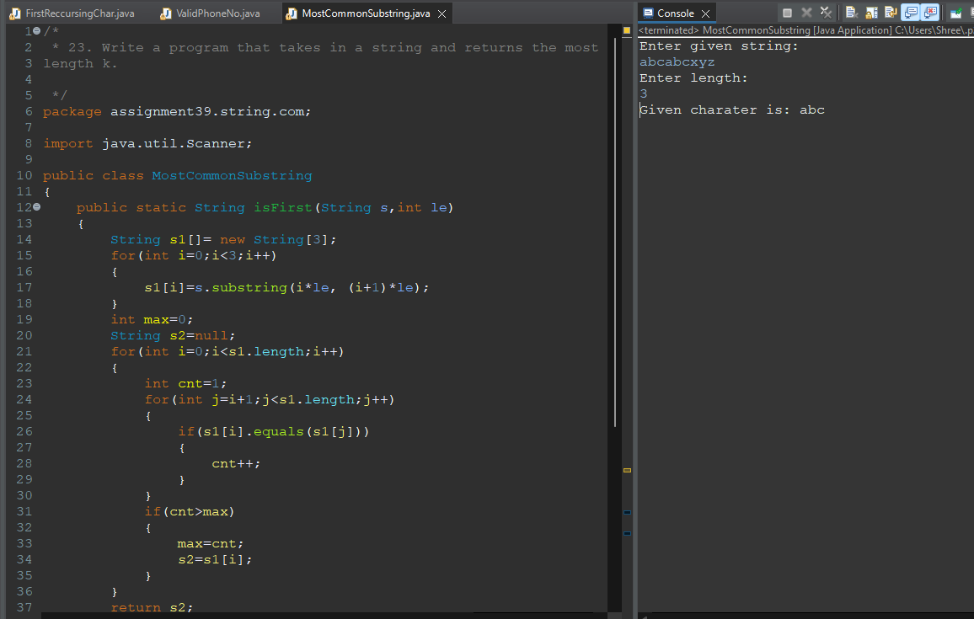

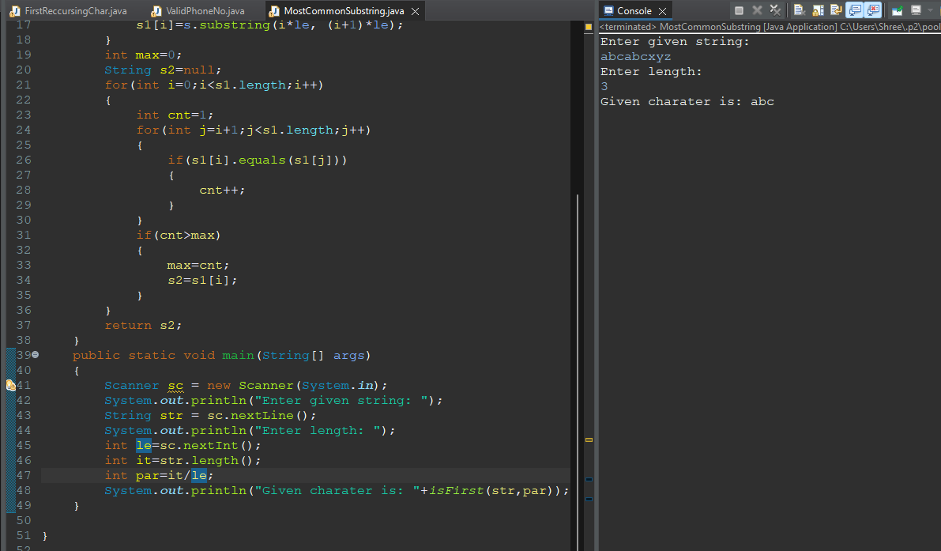

**24. Write a program that takes in a string and checks if it contains only ASCII characters.**

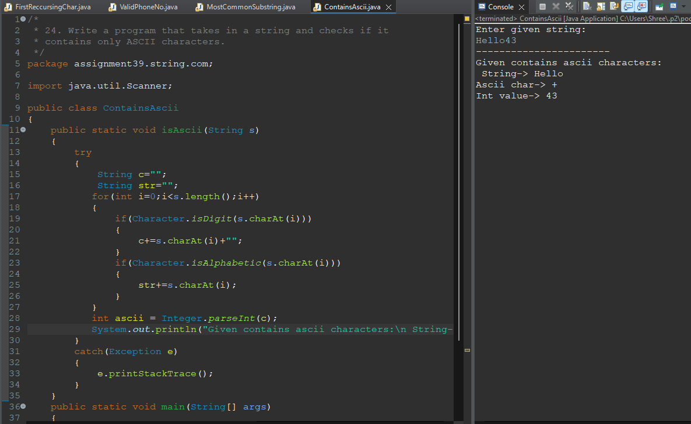

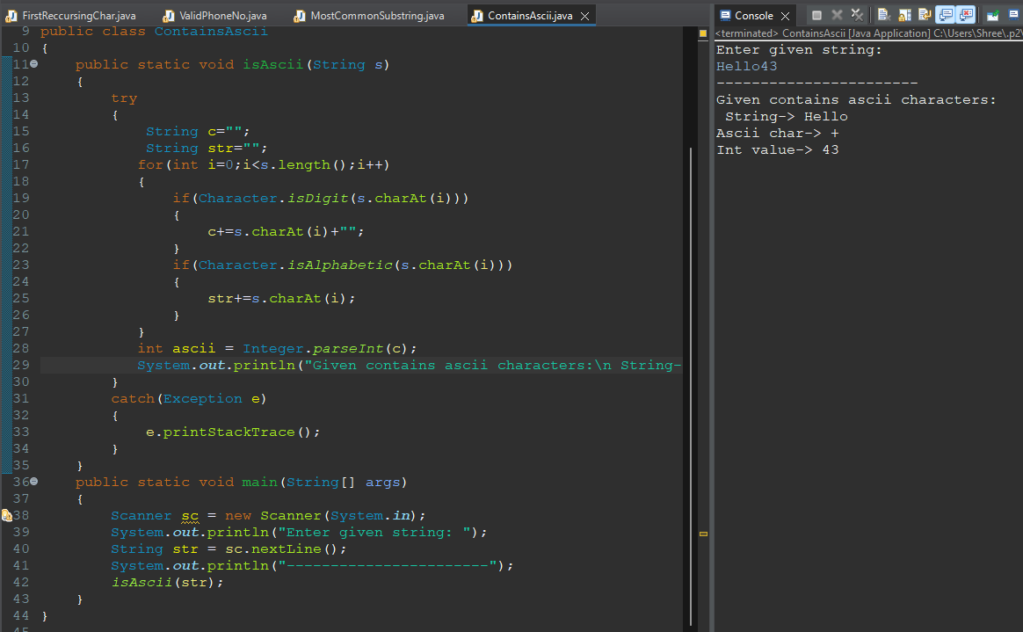

**25. Write a program that takes in a string and returns the number of words in it.**

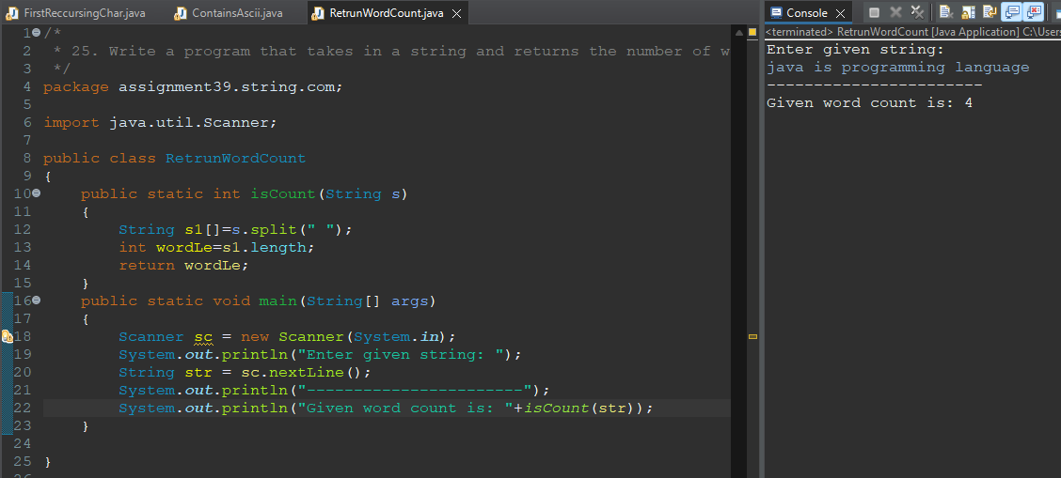

**26. Write a program that takes in a string and removes all leading and trailing whitespace**

**characters.**

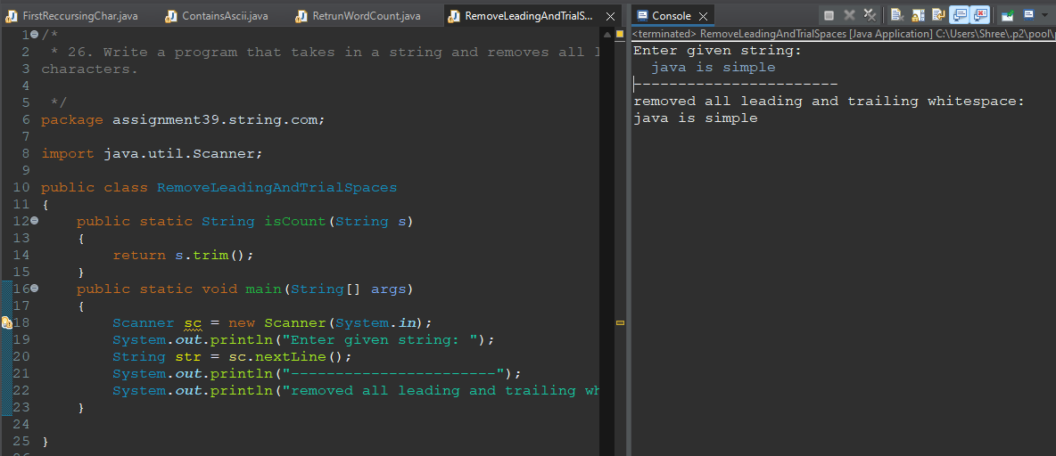

**27. Write a program that takes in a string and returns the index of the first occurrence of**

**a given substring.**

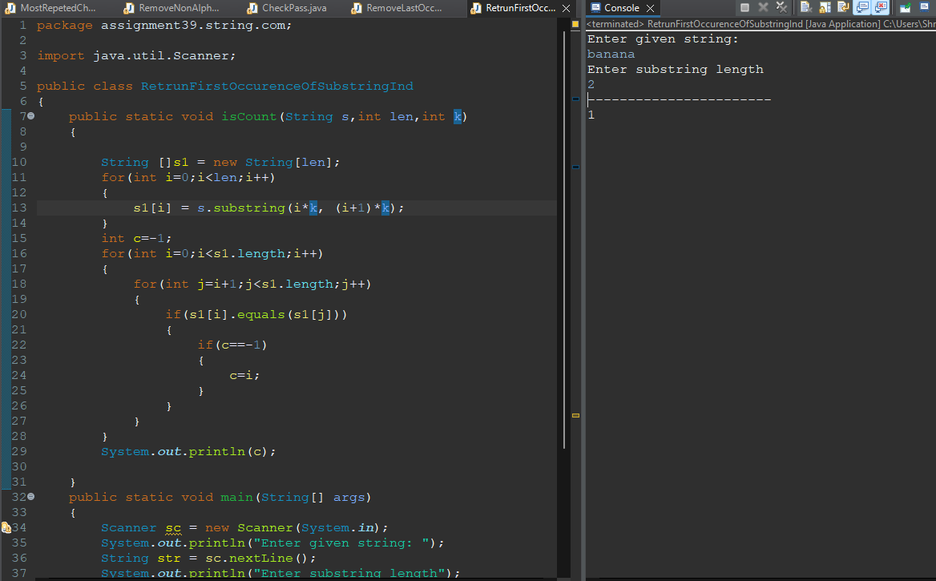

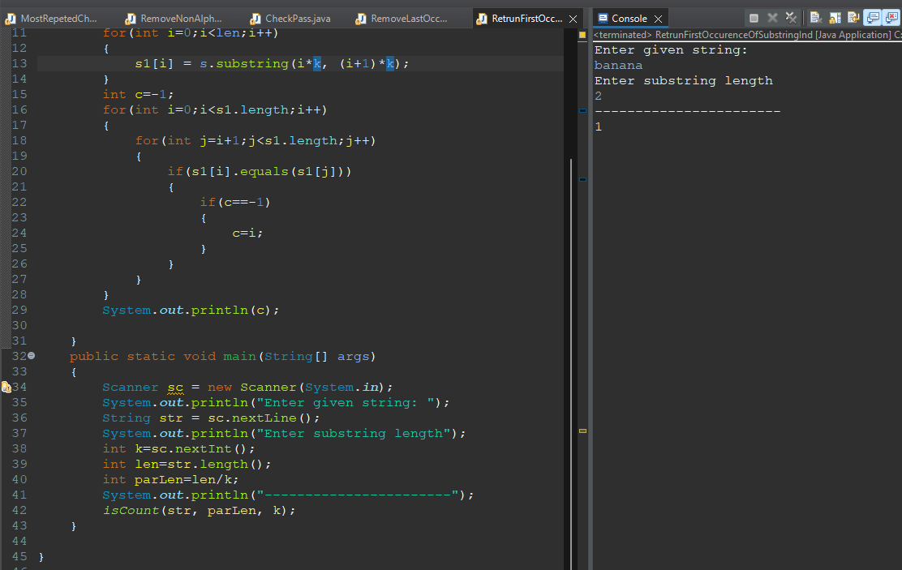

**28. Write a program that takes in a string and returns the character that appears the most**

**in the string, breaking ties alphabetically.**

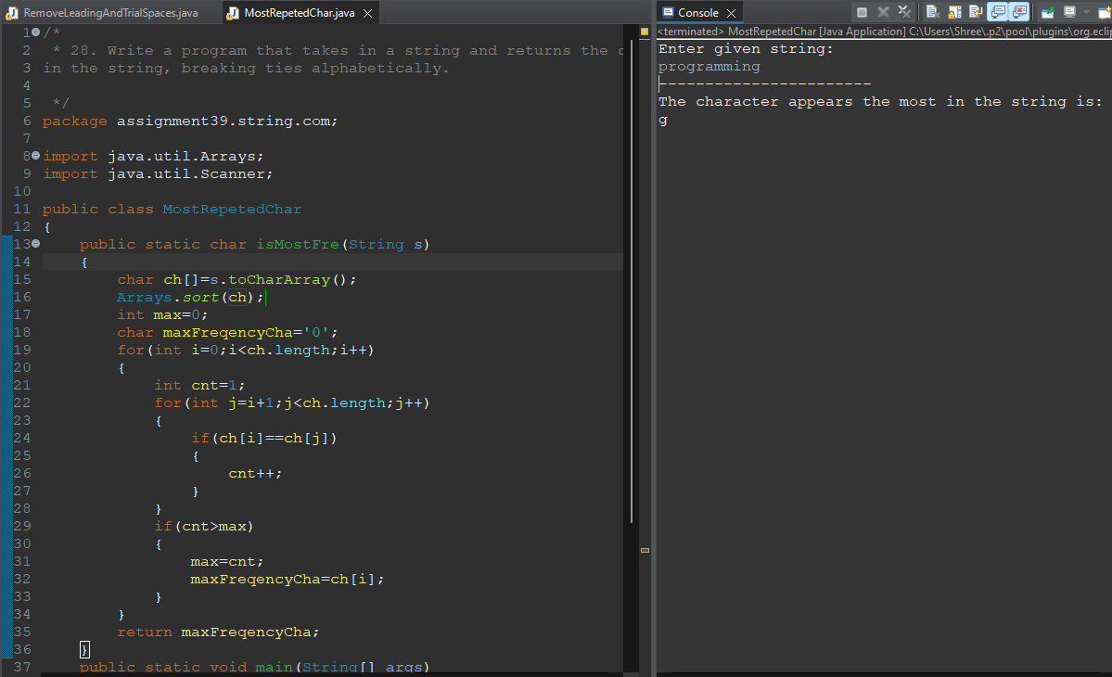

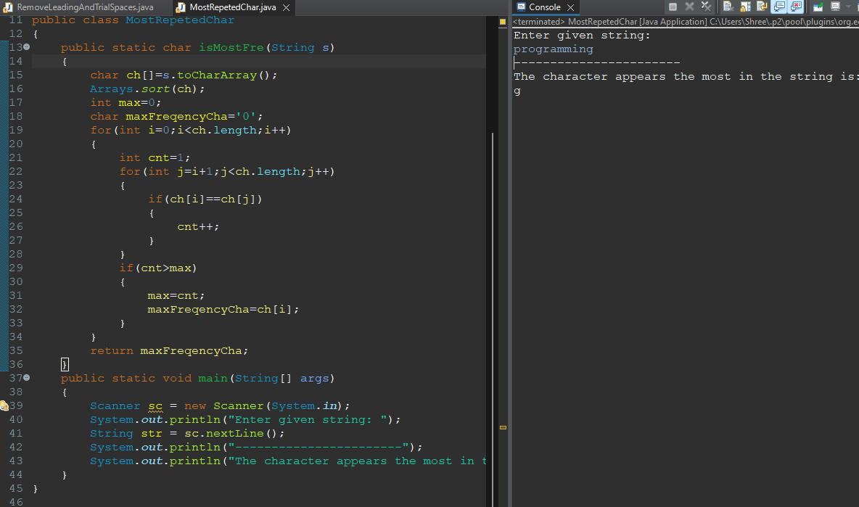

**29. Write a program that takes in a string and returns the number of times each character**

**appears in it.**

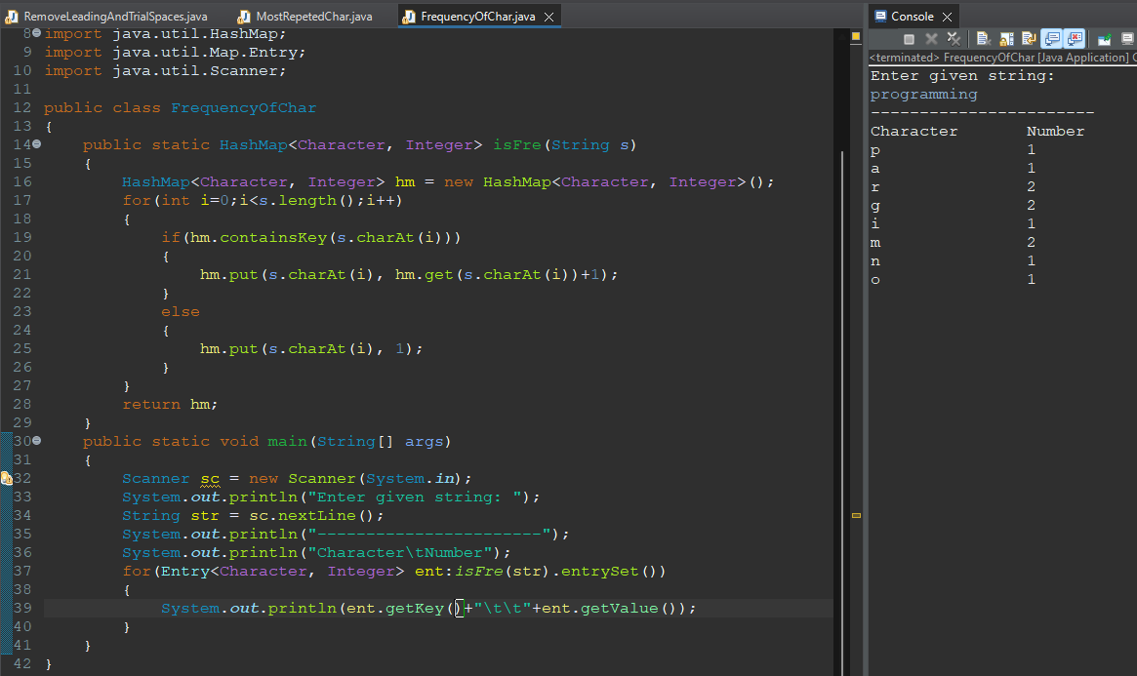

**30. Write a program that takes in a string and removes all characters that are not**

**alphanumeric.**

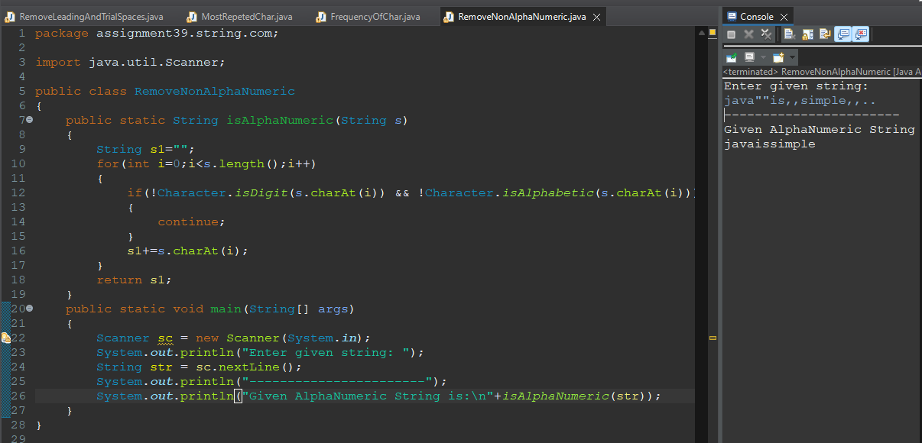

**31. Write a program that takes in a string and checks if it is a valid password (meets**

**certain requirements such as length, complexity, etc.).**

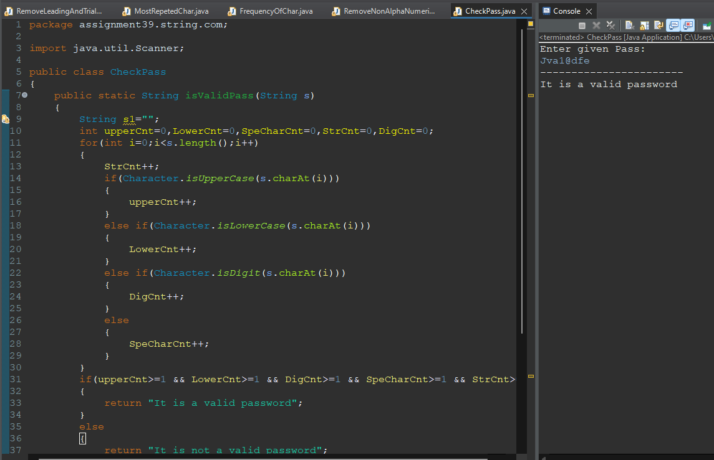

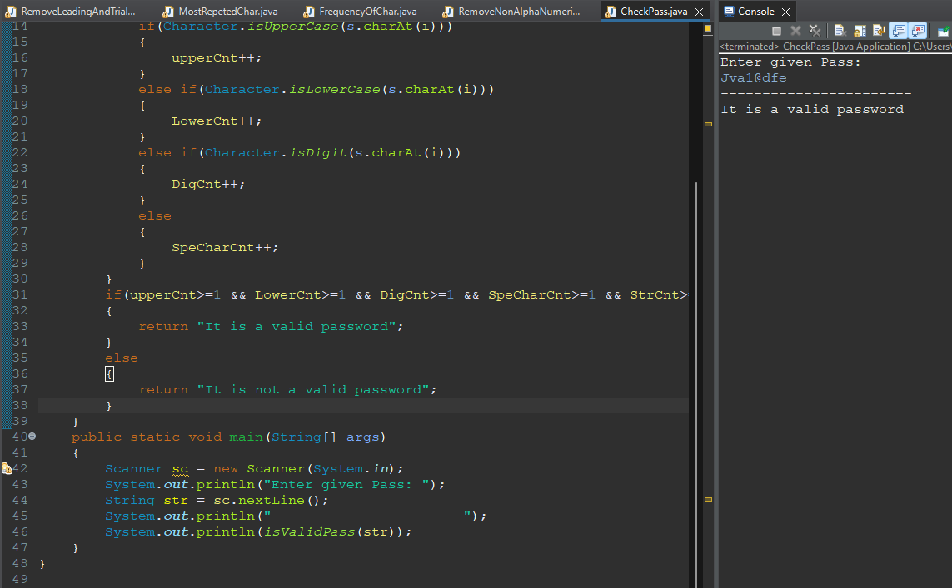

**32. Write a program that takes in a string and returns the index of the last occurrence of**

**a given substring.**

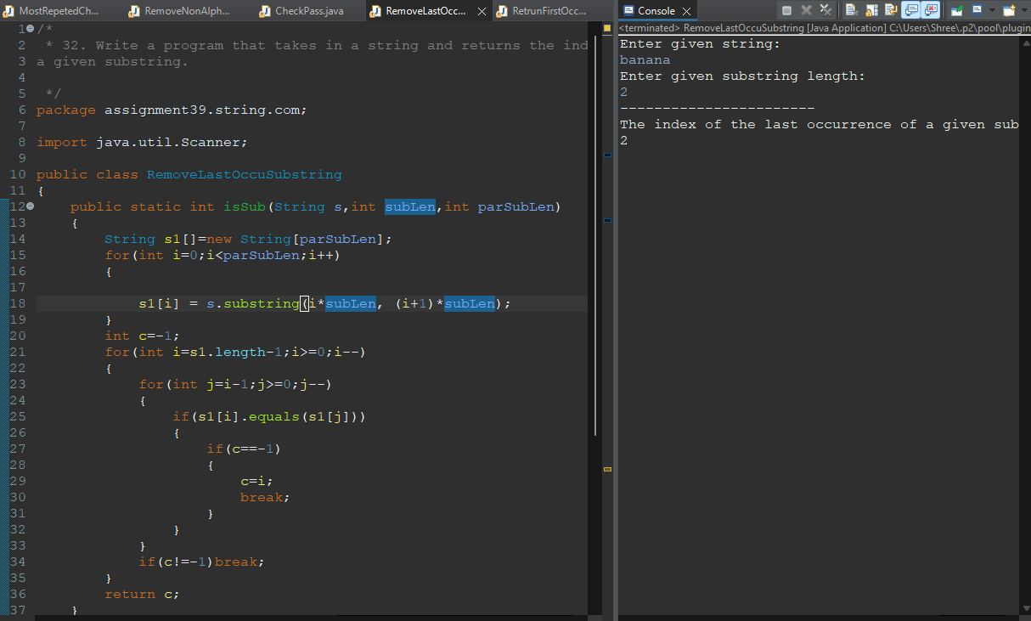

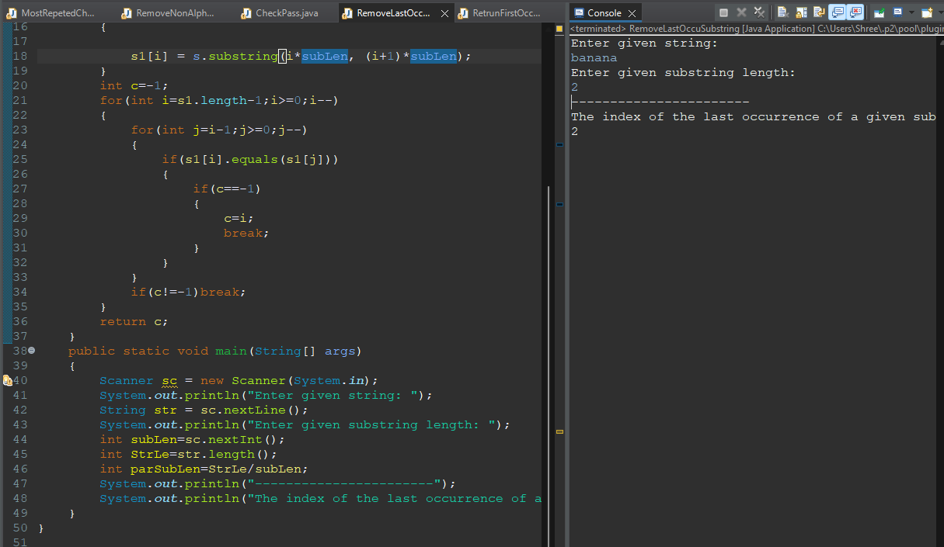

**33. Write a program that takes in a string and checks if it is a pangram (contains all**

**letters of the alphabet).**

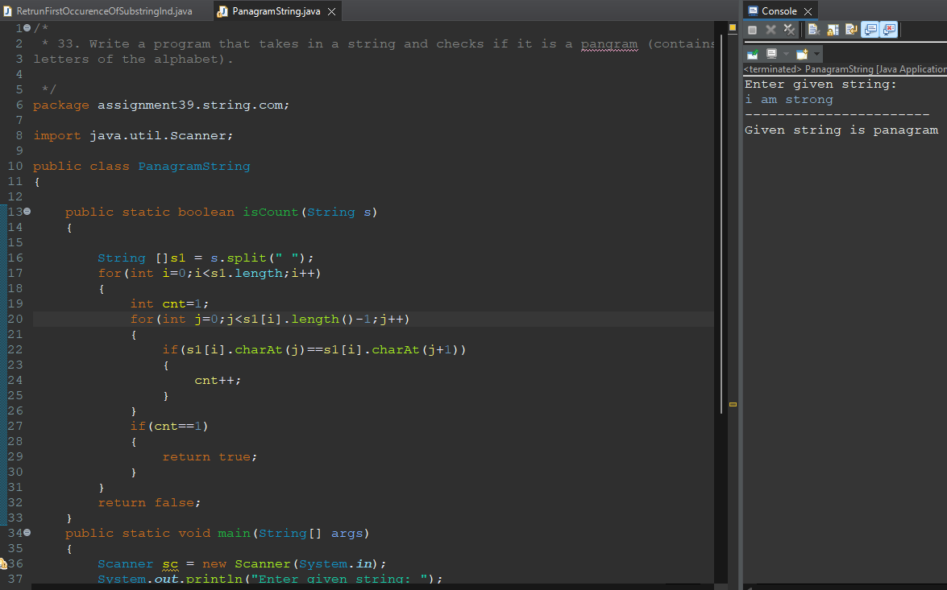

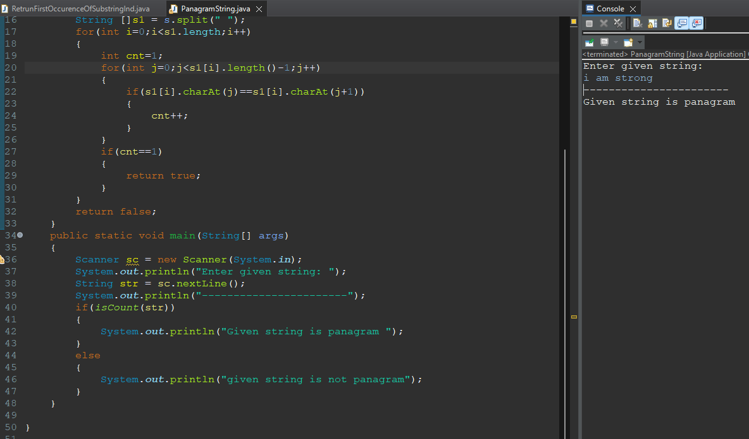

**34. Write a program that takes in a string and returns the most common word in it.**

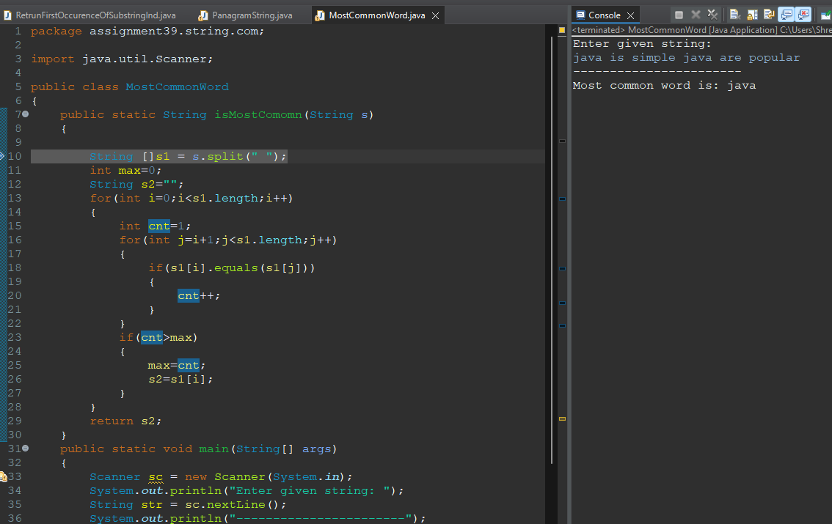

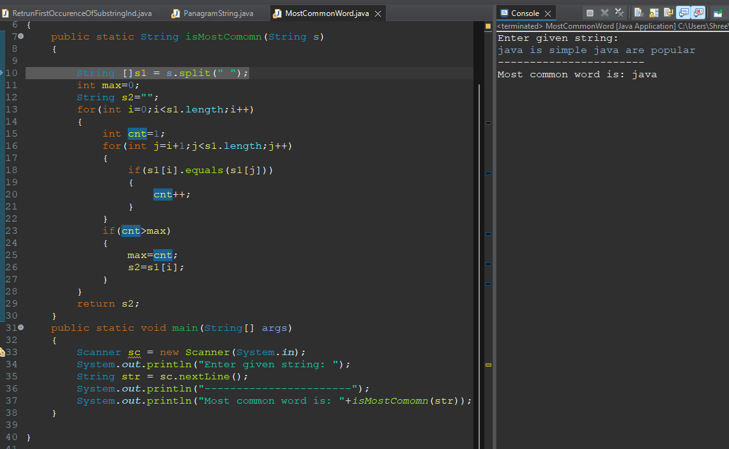

**35. Write a program that takes in a string and returns the number of occurrences of each**

**word in it.**

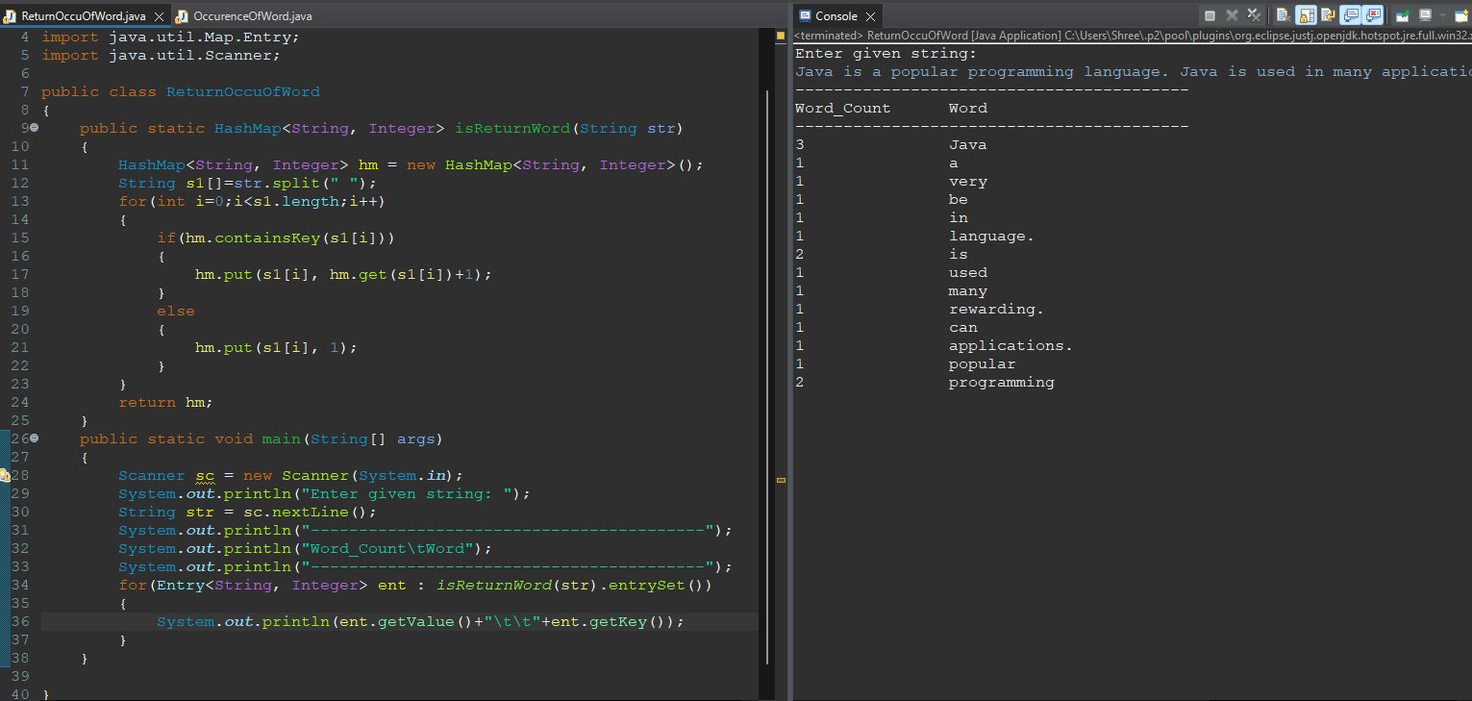

**36. Write a program that takes in a string and returns a new string with all the words**

**reversed.**

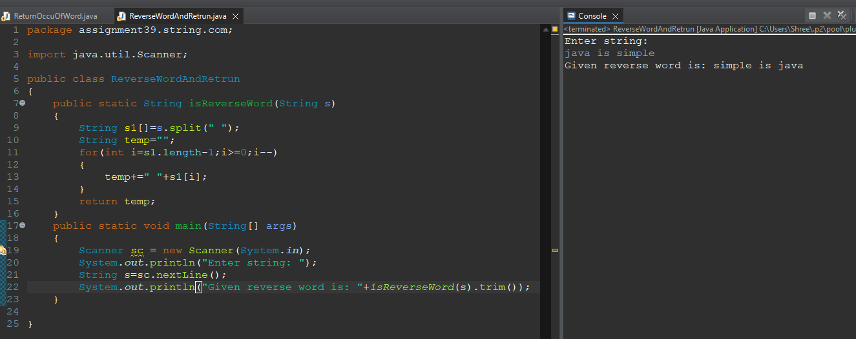

**37. Write a program that takes in a string and returns the first n words.**

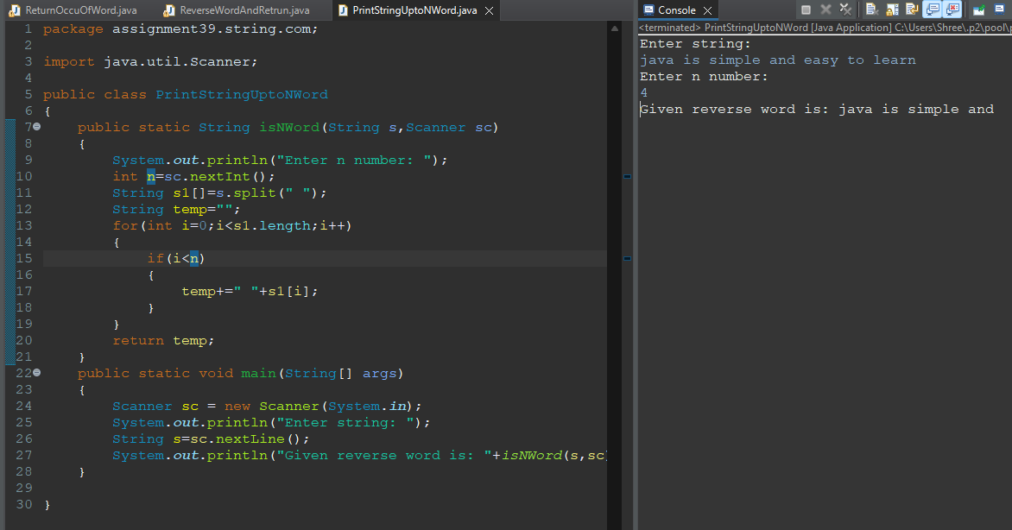

**38. Write a program that takes in a string and returns the last n words.**

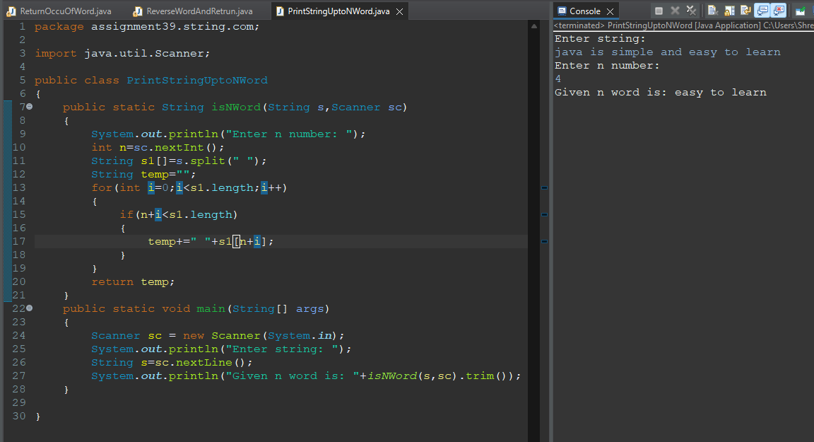

**39. Write a program that takes in a string and checks if it is a valid Roman numeral.**

**40. Write a program that takes in a string and returns the number of times a given word**

**appears in it.**

**41. Write a program that takes in a string and returns the longest common prefix of all the**

**words in it.**

**42. Write a program that takes in a string and checks if it is a valid XML document.**

**43. Write a program that takes in a string and returns the smallest lexicographically**

**rotated version of it.**

**44. Write a program that takes in a string and replaces all spaces with a given character.**

**45. Write a program that takes in a string and returns the words sorted by length.**

**46. Write a program that takes in a string and checks if it is a valid JSON document.**

**47. Write a program that takes in a string and returns the number of times each character**

**appears in it, ignoring case.**

**48. Write a program that takes in a string and removes all consecutive vowels.**

**49. Write a program that takes in a string and returns the length of the longest substring**

**that contains no repeating characters.**

**50. Write a program that takes in a string and returns the words in reverse order.**

**51. Write a program that takes in a string and returns the length of the shortest substring**

**that contains all vowels.**

**52. Write a program that takes in a string and returns the number of times each word**

**appears in it, ignoring the case.**

**53. Write a program that takes in a string and returns a new string with all the vowels**

**replaced with a given character.**

**54. Write a program that takes in a string and returns the longest substring that contains**

**only distinct characters.**

**55. Write a program that takes in a string and returns the words sorted alphabetically.**

**56. Write a program that takes in a string and returns the number of times each character**

**appears in it, ignoring whitespace and case.**

**57. Write a program that takes in a string and returns the number of times each word**

**appears in it, sorted by frequency.**

**58. Write a program that takes in a string and returns the length of the longest**

**palindrome that can be formed by rearranging its characters.**

**59. Write a program that takes in a string and returns a new string with all the words in**

**reverse order and their letters reversed as well.**

**60. Write a program that takes in two strings and returns their longest common**

**subsequence.**

**61. Write a program that takes in a string and returns a new string with all the words**

**reversed, but the order of the words preserved.**

**62. Write a program that takes in a string and returns a new string with all the consonants**

**replaced with a given character.**

**63. Write a program that takes in a string and returns the length of the longest substring**

**without repeating characters.**

**64. Write a program that takes in a string and returns a new string with all the words in**

**reverse order, but the letters of each word in the original order.**

**65. Write a program that takes in a string and returns the length of the longest substring**

**that is a palindrome.**

**66. Write a program that takes in a string and returns a new string with all the words**

**sorted by the number of vowels they contain.**

**67. Write a program that takes in a string and returns a new string with all the characters**

**replaced with their ASCII codes.**

**68. Write a program that takes in a string and returns a new string with all the words**

**sorted by the number of consonants they contain.**

**69. Write a program that takes in a string and returns a new string with all the words**

**sorted by the sum of the ASCII codes of their letters.**